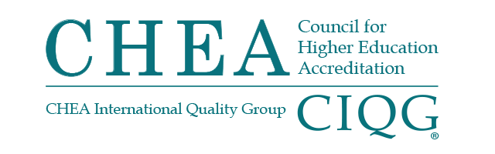

BOARD OF DIRECTORS MEETING
Monday, January 23, 2023
1:00 p.m. – 2:15 p.m.

Summary of Major Actions and Discussion

(These are not official minutes of the CHEA Board of Directors.)

Chair Glickman called the meeting to order at 1:00 p.m.

TREASURER’S REPORT
The board of directors:
- Received the FY23 first and second quarter financial report.
- Received an update on FY23 institutional membership.
CHAIR’S REPORT
The board of directors, upon recommendation from the Committee on Recognition acted to award the maximum term of recognition (seven years) to the American Occupational Therapy Association-Accreditation Council for Occupational Therapy Education (AOTA-ACOTE), National Accrediting Agency for Clinical Laboratory Sciences (NAACLS), Further, the board of directors acted to defer a recognition decision for one year for the Association of Reformed Theological Seminaries-Commission on Accreditation (ARTS-COA).

Vice Chair King reported that, during the Working Session, the board received a report from the Reserve, Investment and Audit Committee. The board was informed of the finalization of updated Board Bylaws to be signed in February 2022. There was also a Board Task Team engagement update.
At the working session the board received a report from the Reserve, Investment and Audit Committee that included an update on CHEA’s investments. There was also a Board Task Team engagement update provided by Vice Chair Dottie King.
The board was also updated on CHEA engagement with the Accreditation Advisory Council.
Government Affairs Report
Senior Vice President for Government Relations Jan Friis reported on the impact of the 2022 elections on U.S. House of Representatives and U. S. Senate Education Committees. The Republicans are the majority in the House and Virginia Foxx (R-NC) will be the Chair, with Bobby Scott (D-VA) the Ranking Member. Republicans will hold the majority of Committee seats with a significant number of new members on the committee.
He reported that in the U.S. Senate, the Democrats will have a one seat advantage on the HELP Committee. Senator Bernie Sanders (D-VT) with chair the Committee with Senator Bill Cassidy (R-LA) as the Ranking Member. They will likely focus on health more that education due to the interests of the lead members of the Committee.
Friis also reported on the U.S. Department of Education (USDE) regulatory agenda. Some proposed rules are coming in the spring. USDE is also planning to hold additional rulemakings, potentially including accreditation, state authorization and distance education.
President’s Update
2023 Annual Conference
Special Assistant to the President Joel Espinoza updated the board on the 2023 CHEA\CIQG Annual Conference taking place January 23-26, 2023, in Washington DC. The meeting was adjourned at 1:16 p.m.

The next meeting of the CHEA Board of Directors will take place
May 1, 2023, in Washington, DC.

