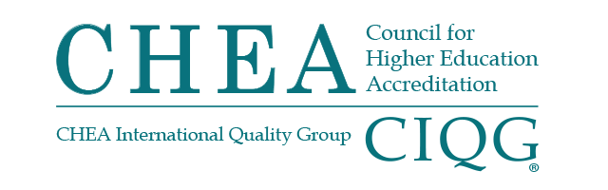

BOARD OF DIRECTORS MEETING
MONDAY, OCTOBER 4, 2021
VIRTUAL MEETING
4:00 p.m. – 5:00 p.m.

Summary of Major Actions and Discussion

(These are not official minutes of the CHEA Board of Directors.)

Chair Gena Glickman called the meeting to order at 4:01 p.m.
TREASURER’S REPORT
The board of directors:
- Received the FY21 external audit as presented.
- Received the FY21 fourth quarter financial report.
- Received an update on FY21 institutional membership.
CHAIR’S REPORT
During the Working Session:
Government Affairs Report
Senior Vice President Jan Friis reported that U.S. Senate confirmed James Kvaal as Under-Secretary of Education, He reported on the current negotiated rulemaking and upcoming public hearings for additional rulemaking.
Friis discussed Education Committee hearings and legislation concerning accreditation which could permit the Secretary of Education’s approval of accreditor standards. He also discussed the amount of time consumed by the congressional negotiations over the infrastructure bill, the reconciliation package and the debt ceiling debate, leaving time for little else.
Friis reported that National Advisory Committee on Institutional Quality and Integrity is looking to expand its role including recommending standards for accreditors and that CHEA continues its work with Washington associations.
President’s Update
At the Working Session, the board approved revisions to the 2019 CHEA Recognition Policy and Standards. They also approved revisions to the CHEA Bylaws.
President Jackson-Hammond announced that the 2022 CHEA Annual Conference will be hybrid and take place January 24-27, 2022.

Appointment of 2021-2021 Committees
During the board meeting, board members indicated their preferences for committee participation. Committee membership for 2021-2022 is as follows:
Reserve, Investment and Audit Committee
Robert Clark, Chair
Joseph Brimhall
Bud Baeslack
Cesar Maldonado
Anthony Munroe
James Willis (CHEA staff resource)

Committee on Directors
Dottie King, Chair
Kassandra Ardinger
Colette Pierce Burnette
Javier Cevallos
Sharon DeVivo
Cynthia Jackson-Hamond (CHEA staff resource)

Committee on Membership
Lester Newman, Chair
Pauletta Brown Bracy
Darrell Cain
Antoine Garibaldi
Cynthia Spiers
Lori Williams
Jean Wyld
Eric Selwyn (CHEA staff resource)
PRESIDENT’S REPORT
Appointments to the Committee on Recognition
The board of directors appointed the following member to the Committee on Recognition:
- Glenda Carter, retired Executive Vice President and Provost, Wiley College to a three-year term (October 2021–December 2023)
The meeting was adjourned at 4:58 p.m.

The next meeting of the CHEA Board of Directors will take place
January 24, 2022, in Washington, DC.

